Parasitic computing
1.About parasitic computing

parasitic computer is an concept by which one can use the resource of machine that are connected on the Internet this technology exploit oneinternet protocols to use the resource of remote machines as the name suggests that the machine that requires the service of other does not need to be authorised by the letter any machine which is connected to the internet has to carry out minimum processing of any packet they received without any authorisation

Parasitic computer can be a very effective technique when it's come to solve NP complete program subject circuit SAT,3SAT etc this problems are currently considered as sum of world's most complex and time-consuming problems with these problems generally have a set of solution which itself is a subset of a set of possible solution

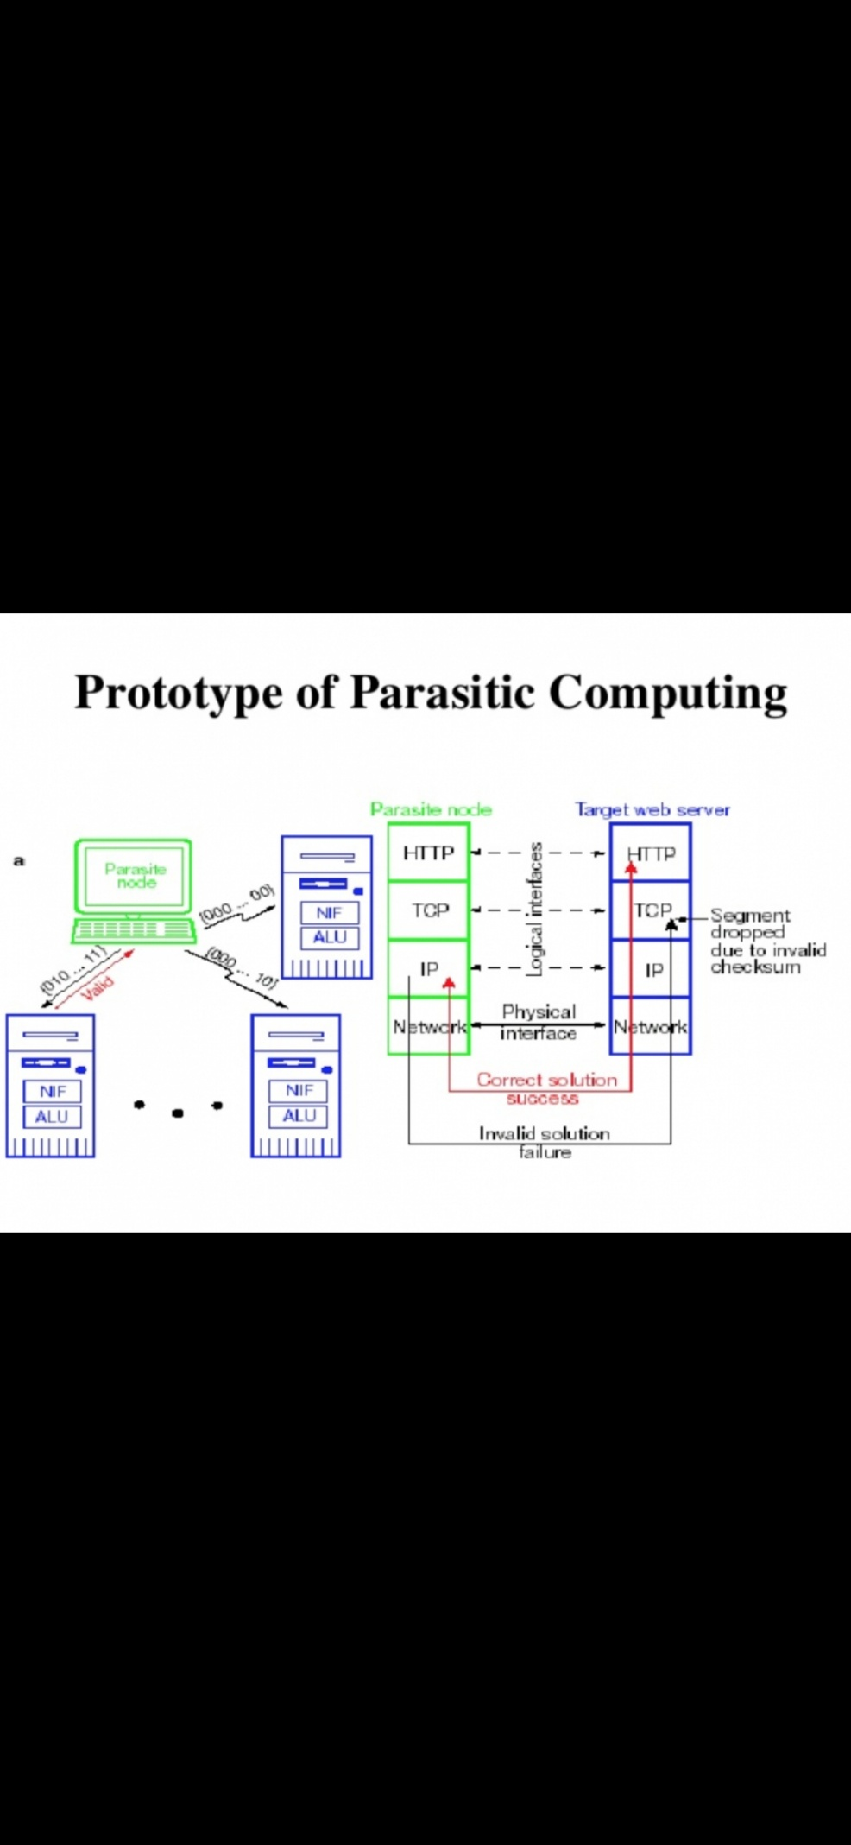
Figure

It was first proposed by Albert-Laszlo Barabasi, Vincent W. Freeh, Hawoong Jeong & Jay B. Brockman from University of Notre Dame, Indiana, USA, in 2001.[1] The example given by the original paper was two computers communicating over the Internet, under disguise of a standard communications session. The first computer is attempting to solve a large and extremely difficult 3-SATproblem; it has decomposed the original 3-SAT problem in a considerable number of smaller problems. Each of these smaller problems is then encoded as a relation between a checksum and a packet such that whether the checksum is accurate or not is also the answer to that smaller problem. The packet/checksum is then sent to another computer. This computer will, as part of receiving the packet and deciding whether it is valid and well-formed, create a checksum of the packet and see whether it is identical to the provided checksum. If the checksum is invalid, it will then request a new packet from the original computer.

How parasitic computing work
all through any possible solution to such problems can be verified quickly there is no known efficient way to identify a solution in the first place in fact the notable characteristic of for such problems is that there is no fast solution the time required to solve such problem is exponentially proportional to the size of the problems such as the size of the problem growth the time required to find all solution of the problems grows exponentially in fact time required to solve a moderately large np-complete program can easily read billions if not millions of years using any kind of modern computing Technology we have available today for this reason even just and determining whether there is a fast solution to such problems or not is on the principal and solve problem of computer science
Parasitic computing start the process by transmitting specially generated message to number to target web server constructing of arithmetic and logic unit and a network interface and NIF the packet carrying on of the possible solution to the problems is inserted into the IP level bypassing the parasitic not TCP
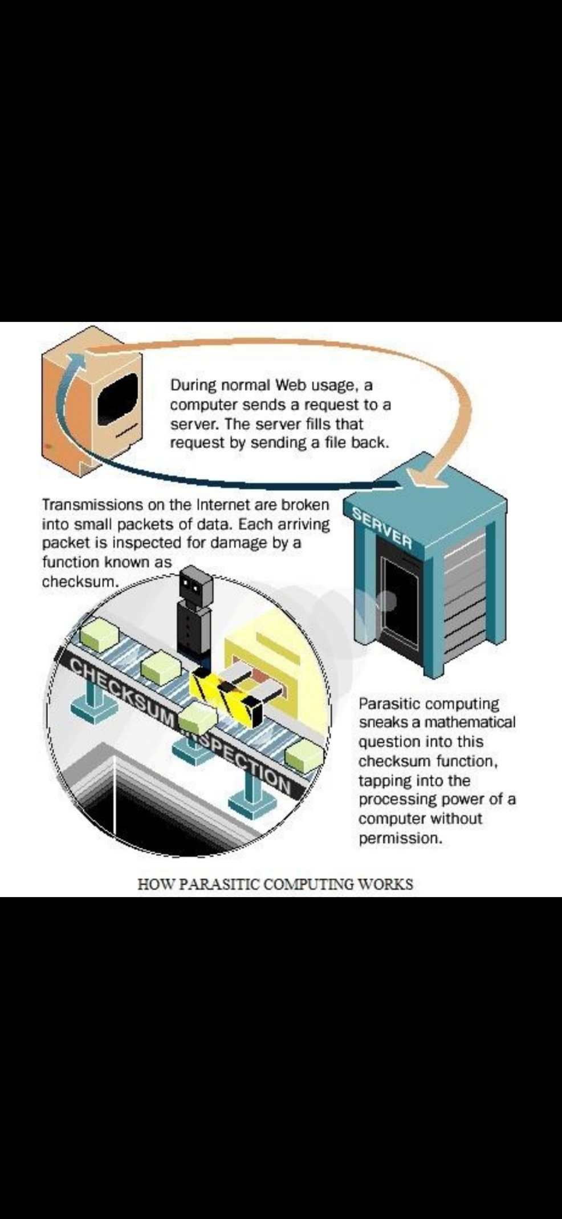
Figure 2: how parasitic computing work
The parasitic computer generates a message in such a way that if the solution is not valid, it will fail the TCP checksum on the destination machine and the packet will be dropped. But in the case when the solution is correct, it will be propagated to the HTTP layer via TCP. Since it is a behavior of a web server to respond to any requests coming to an HTTP layer regardless of whether it understands the request or not, the web server will send a response back to the parasitic computer that it has received an HTTP request.

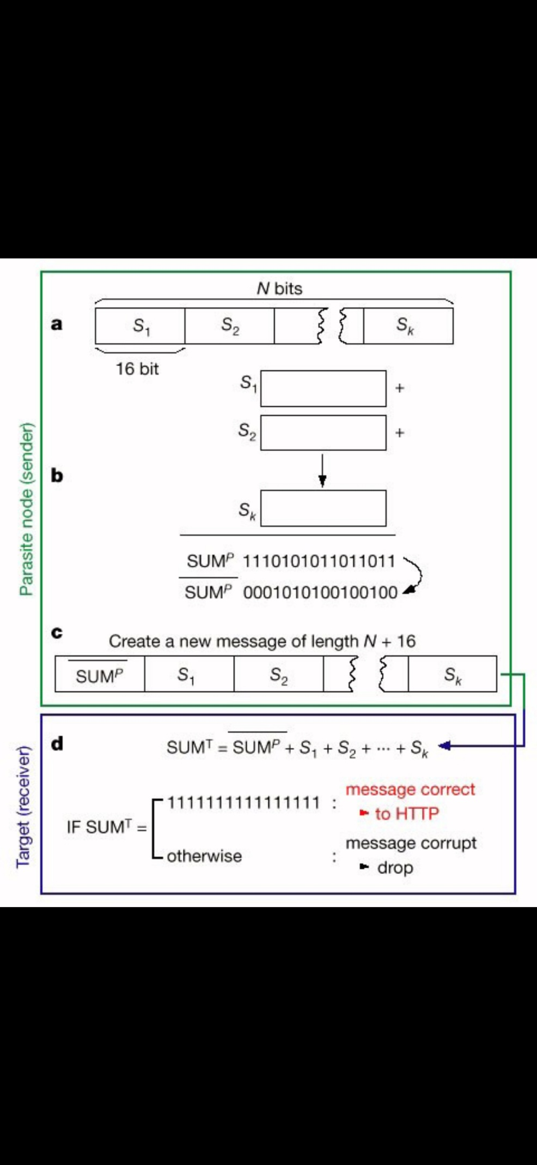
Fig 3.Parasitic node sender

6. conclusion
Parasitic computing moves computation onto what is logically the communication infrastructure of the Internet, blurring the distinction between computing and communication. The Notre Dame scientists have shown that the current Internet infrastructure permits one computer to instruct other computers to perform computational tasks that are beyond the target's immediate scope. Enabling all computers to swap information and services they are needed could lead to unparalleled emergent behavior, drastically altering the current use of the Internet.
The implementation offered above represents only a proof of concept of parasitic computing. As such, the solution merely serves to illustrate the idea behind parasitic computing, and it is not efficient for practical purposes in its current form.

References

- Albert-Laszlo Barabasi, Vincent W. Freeh, Hawoong Jeong & Jay B. Brockman from University of Notre Dame, Indiana, USA, in 2001

